**Automated SSL Termination in EKS with Cert Manager(Venafi-Cloud)**

Jaswanth Kumar Jonnalagadda

Amazon Web Services

October 2019



© 2019 Amazon Web Services, Inc. or its affiliates. All rights reserved. This work may not be reproduced or redistributed, in whole or in part, without

prior written permission from Amazon Web Services, Inc. Commercial copying, lending, or selling is prohibited.  
All trademarks are the property of their owner

Table of Contents

Kubernetes Cert-Manager: 3

Pre-Requisite: 3

Installing Cert-Manager: 3

Verifying Functionality: 4

Configuring Issuer: 5

Configuring with Venafi Cloud Issuer: 5

# **Kubernetes Cert-Manager**:

cert-manager is a native Kubernetes certificate management controller.

cert-manager can help with issuing certificates from a variety of sources, such as Let’s Encrypt, HashiCorp Vault, Venafi, a simple signing keypair, or self-signed. cert-manager will ensure certificates are valid and up to date, and attempt to renew certificates at a configured time before expiry.

Architecture:

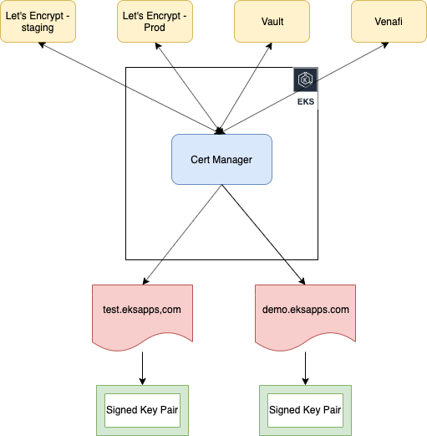

# **Pre-Requisite**:

Following are the expected perquisites for the cert manager to issue certificate dynamically.

1. Fully functional EKS cluster.
2. Domain of your own.

# **Installing Cert-Manager**:

Follow the below steps to install cert-manager in the EKS cluster.

1. Create a separate namespace in the EKS cluster for cert-manager
   * **kubectl create namespace cert-manager**

cat <<EOF > sample-resources.yaml

apiVersion: v1

kind: Namespace

metadata:

name: cert-manager-check

---

apiVersion: cert-manager.io/v1alpha2

kind: Issuer

metadata:

name: test-selfsigned

namespace: cert-manager-test

spec:

selfSigned: {}

---

apiVersion: cert-manager.io/v1alpha2

kind: Certificate

metadata:

name: selfsigned-cert

namespace: cert-manager-test

spec:

commonName: example.com

secretName: selfsigned-cert-tls

issuerRef:

name: test-selfsigned

EOF

1. Install cert manager in the namespace with the below command.
   * **kubectl apply -f** [**https://github.com/jetstack/cert-manager/releases/download/v0.11.0/cert-manager.yaml**](https://github.com/jetstack/cert-manager/releases/download/v0.11.0/cert-manager.yaml) **--validate=false**

**\*\*** Reason for the –validate=false tag is to overcome the way kubectl performs resource validation on kubernetes version less that 1.15

1. Verify Installation with the below command
   * **kubectl get pods --namespace cert-manager**
   * If everything went well we will see three pods in running state as shown
   * To view the custom resources that are deployed along with cert-manager, run the following command: **kubectl get crd --all-namespaces**

## **Verifying Functionality:**

1. Build a sample self-signed certificate issuer in the cluster with the following script
2. Execute the script with the command
   * **Kubectl apply -f sample-resources.yaml**
3. Wait for few seconds for the cert-manager to process the certificate request.
   * Execute the command to describe the generated certificate
   * **Kubectl describe cert -n cert-manager-test**

You should see a similar output

With this we can confirm that the cert manager is installed without any errors.

Clean up test resources with the command: **kubectl delete -f sample-resources.yaml**

# **Configuring Issuer:**

Before you can begin issuing certificates, you must configure at least one Issuer or ClusterIssuer resource in your cluster.

These represent a certificate authority from which signed x509 certificates can be obtained, such as Let’s Encrypt, or your own signing key pair stored in a Kubernetes Secret resource. They are referenced by Certificate resources in order to request certificates from them.

An Issuer is scoped to a single namespace, and can only fulfill Certificate resources within its own namespace. This is useful in a multi-tenant environment where multiple teams or independent parties operate within a single cluster.

On the other hand, a ClusterIssuer is a cluster wide version of an Issuer. It is able to be referenced by Certificate resources in any namespace.

In this article we will use Venafi cloud to explain issuer for a namespace scope

## **Configuring with Venafi Cloud Issuer**:

1. Deploy an ingress-nginx using an ELB to expose the service.

Run the following commands to deploy the ingress controller.

* kubectl apply -f <https://raw.githubusercontent.com/kubernetes/ingress-nginx/master/deploy/static/mandatory.yaml>
* kubectl apply -f <https://raw.githubusercontent.com/kubernetes/ingress-nginx/master/deploy/static/provider/aws/service-nlb.yaml>

** It will take few minutes for the ingress controller to be up.

1. Verify the deployed service with the command: **kubectl get service -n ingress-nginx**

Sample Output:



** If the external-ip is not available, please wait for few minutes for the address to be issued.

1. Once the external ip is issued, then verify if the traffic is being routed to the ingress-nginx

Command: **curl http:// a8a40d7a7eef511e9a9320e7de11db72-b1e2865cb8933f90.elb.us-east-1.amazonaws.com**

Sample Output:

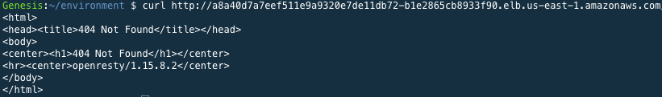

1. Now that our NLB has been provisioned, we should point our application’s DNS records at the NLBs address. In the DNS provider’s console set an A record to pointing to your NLB external ip.

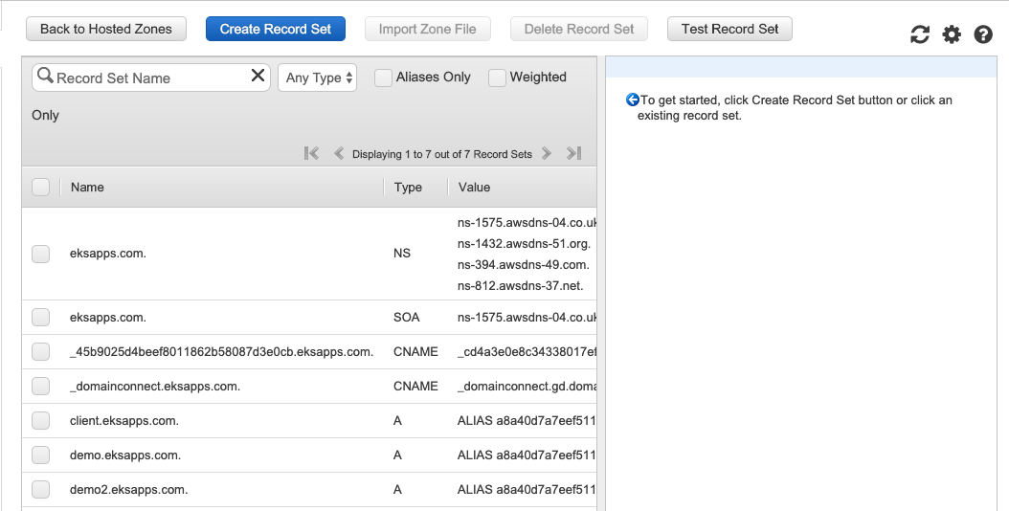

Click on create Record Set

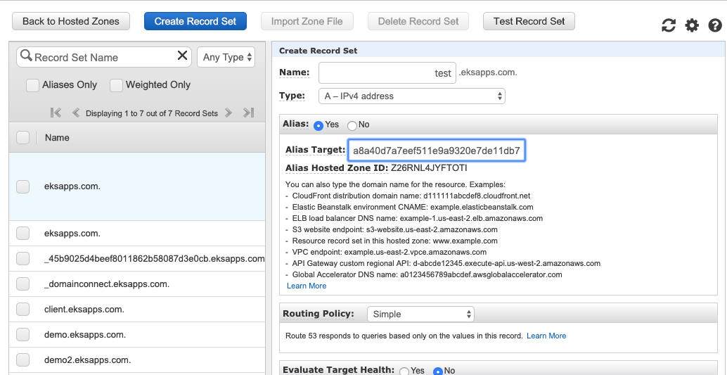

Add the extern ip address

Choose a name

* Click on Create button.
* This will create a new entry in the DNS record set.
* This will resemble following

test.eksapps.com A [http://a8a40d7a7eef511e9a9320e7de11db72-b1e2865cb8933f90.elb.us-east-1.amazonaws.com](http://a8a40d7a7eef511e9a9320e7de11db72-b1e2865cb8933f90.elb.us-east-1.amazonaws.com/)

1. Create a namespace demo
   * Command: kubectl create namespace demo
2. Deploy a sample application in the demo namespace with the below deployment script

Command: **kubectl apply -f demo-application.yml -n demo**

---

apiVersion: v1

kind: Service

metadata:

name: hello-kubernetes

namespace: demo

spec:

type: ClusterIP

ports:

- port: 80

targetPort: 8080

selector:

app: hello-kubernetes

---

apiVersion: apps/v1

kind: Deployment

metadata:

name: hello-kubernetes

namespace: demo

spec:

replicas: 2

selector:

matchLabels:

app: hello-kubernetes

template:

metadata:

labels:

app: hello-kubernetes

spec:

containers:

- name: hello-kubernetes

image: '682651395775.dkr.ecr.us-east-1.amazonaws.com/java_app_one:latest'

resources:

requests:

cpu: 100m

memory: 100Mi

ports:

- containerPort: 8080

1. Verify the application deployment with the below command
   * **Kubectl get po,svc -n demo**

Sample output:

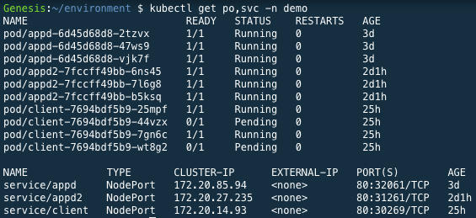

1. Create Venafi Cloud account
   * Visit the url: <https://ui.venafi.cloud/enroll>
   * Create an account with corporate email and login to dashboard
   * Choose Configuration from the left plane
     1. Click on issuing Templates
     2. Create a new temaplate
     3. Sample filled template as shown
     4. Choose built in CA for ease of use.
     5. Common Name must include your domain name.

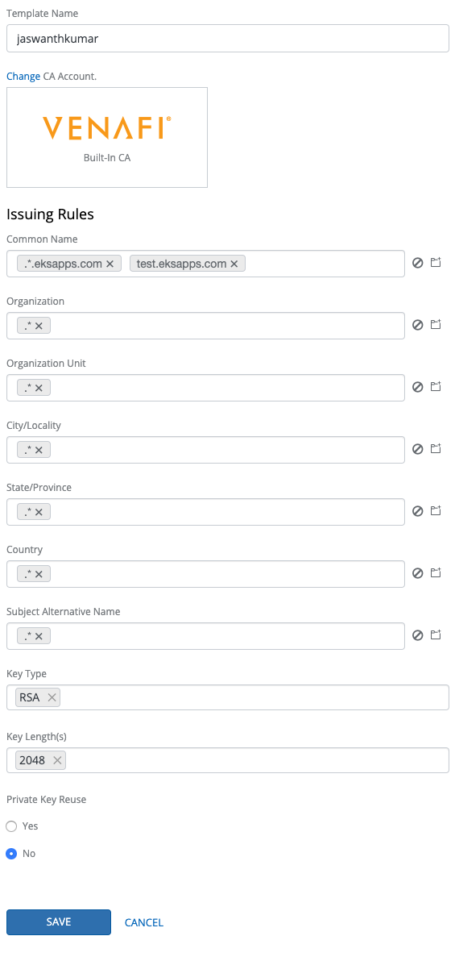

* + 1. Click on save.
  + Click on Projects and choose “Create New Project”
    1. Enter Project Name, Description
    2. Add a Zone
       1. Choose a name for the zone
       2. Choose the the previously created template

Sample zone:

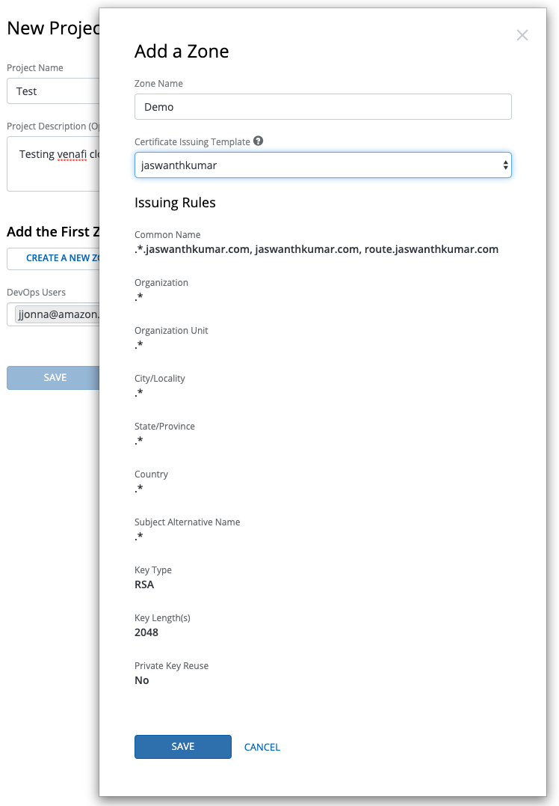

* + - 1. Click on save
      2. And choose a user for DevOps user
      3. Create the project.

1. In the projects plane choose the project created
   * Choose kubernetes to view the configuration for K8

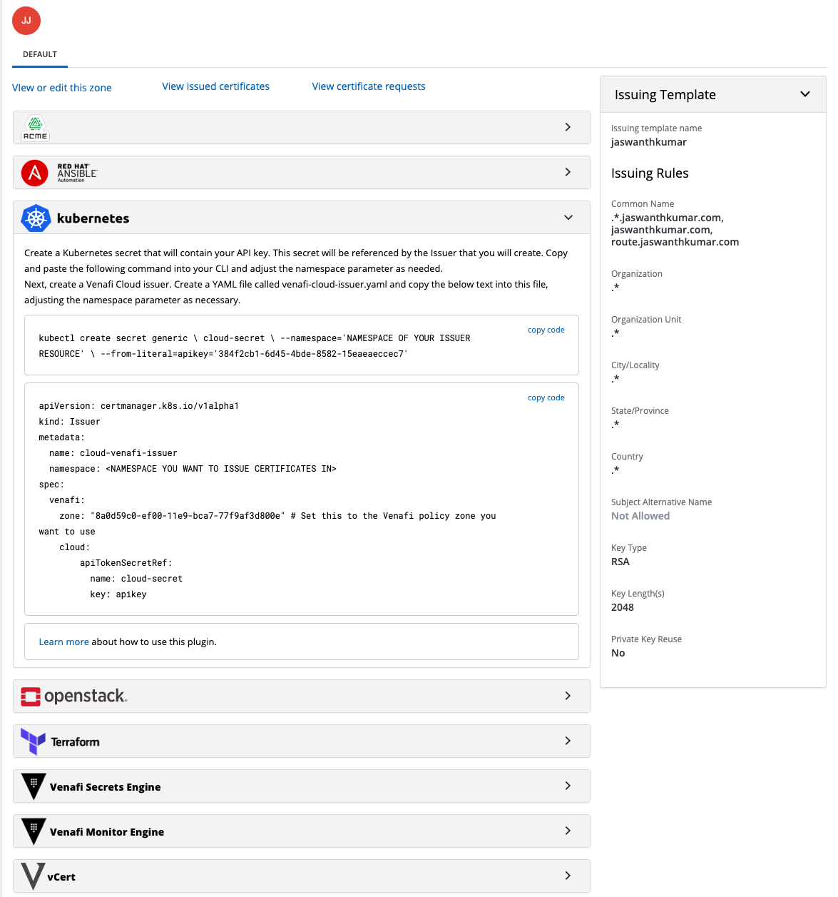

1. With this we had set up a cloud certificate issuer(Venafi Cloud)
2. Once registered, you should fetch your API key by clicking your name in the top right of the control panel interface.

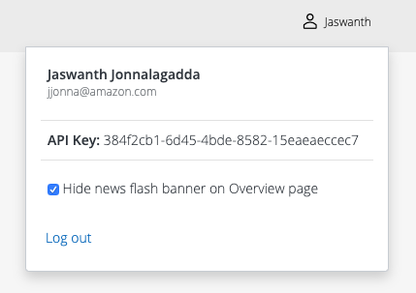

1. In order for cert-manager to be able to authenticate with your Venafi Cloud account and set up an Issuer resource, you’ll need to create a Kubernetes Secret containing your API key
   * kubectl create secret generic \

venafi-cloud-secret \

--namespace=demo \

--from-literal=apikey=**<API_KEY>**

**Replace **<API_KEY>** with API key from venafi cloud account.

1. Create a Venafi certificate issuer with the script below
   * Copy the configuration code from the project and zone you want to use.

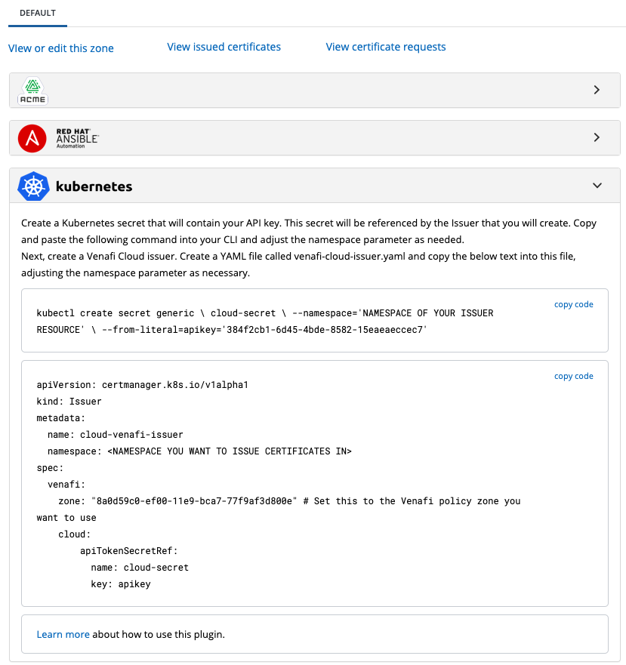

Copy this code into a file venafi-issuer.yaml

1. Replace the secret in the file with the secret generated above.
2. Run the script to deploy the certificate issuer with the command
   * **Kubectl apply -f venafi-issuer.yaml -n demo**
3. Verify the issuer installation with the command
   * **Kubectl describe issuer cloud-venafi-issuer -n demo**

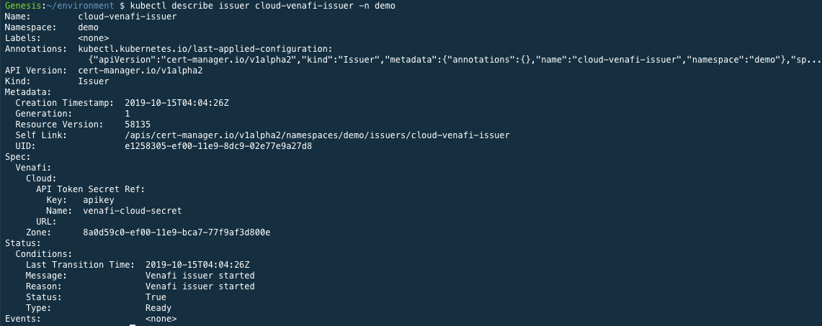

This shows that the issuer had successfully validated itself with the Venafi Cloud service.

1. As the issuer is configured correct, we can now issue a certificate
   * Create a yaml script that can issue a certificate for the domain ‘test.eksapps.com’

** Replace test.eksapps.com with a domain you own.

* + Save the yaml into a file named eksapps-com-tls.yaml

apiVersion: cert-manager.io/v1alpha2

kind: Certificate

metadata:

name: testeksapp-com-tls

namespace: demo

spec:

secretName: testeksapp-com-tls

dnsNames:

- test.eksapps.com

issuerRef:

name: venafi-issuer

Kind: Issuer

* + Run the script with the command

**Kubectl apply -f eksapps-com-tls.yaml -n demo**

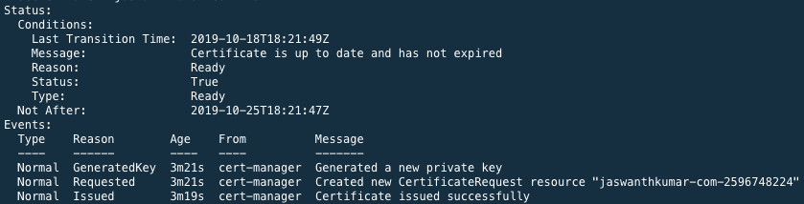

This shows that cert manager had issued a certificate and it is ready to be consumed

1. Now we can expose the application with the kubernetes ingress resource
   * Create a file named application-ingress.yaml

Replace the service with the service deployed

Replace with the name of issuer that create in the namespace

Replace the domain with custom domain

---

apiVersion: extensions/v1beta1

kind: Ingress

metadata:

name: appd

namespace: demo

annotations:

kubernetes.io/ingress.class: "nginx"

cert-manager.io/cluster-issuer: cloud-venafi-issuer

labels:

app: appd

spec:

tls:

- hosts:

- test.eksapps.com

secretName: testeksapp-com-tls

rules:

- host: test.eksapps.com

http:

paths:

- path: /

backend:

serviceName: appd

servicePort: 80

With this we had completely automated the certificate issuing inside EKS cluster.

Now we can login to the browser and reach the website over https

**https://test.eksapps.com**